Lab 4.1

Refer to Tutorial 3: Designing a Page Layout

1. Complete Session 3.1 **pages HTML 178 to HTML 203**

Add a screenshot of the **pc_home.html** file displayed in a browser after completing Step 2 on page HTML 202. Include the browser address bar. Refer to **Figure 3-28** for reference

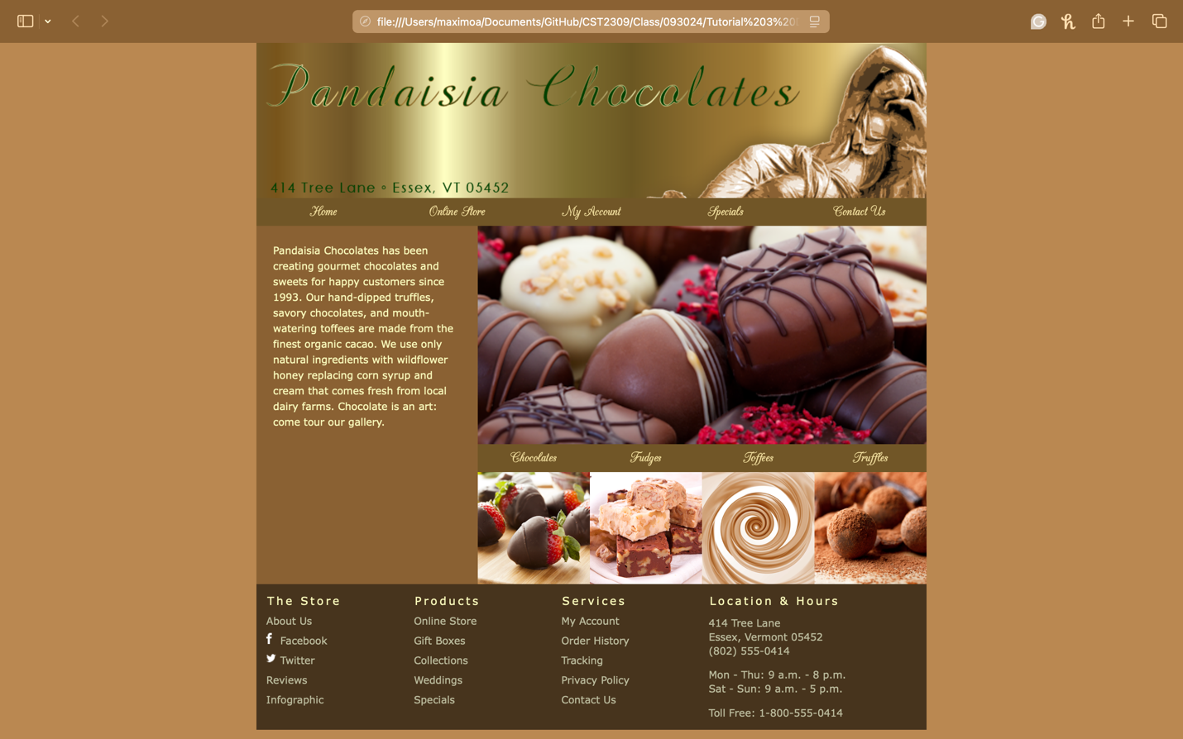

1. Complete the Session 3.1 Quick Check in Blackboard